Game Design Document

I didn’t know what my game was going to be until June. Planning for the game began early 2018 when the theme was released. The aspects that stood out the most from Transformation were the mutation and evolution. I had dabbled in machine learning and neural networks before and was inspired by genetic algorithm simulators on YouTube to create something similar. At first I had no clue what to make, early brainstorms developed ideas like evolving from a fish to a human, training a car how to move through mazes and even a plant growing game. In spite of the continual emphasis on planning, planning, planning, at the time of writing this game document in early April I still don’t know what my game will be

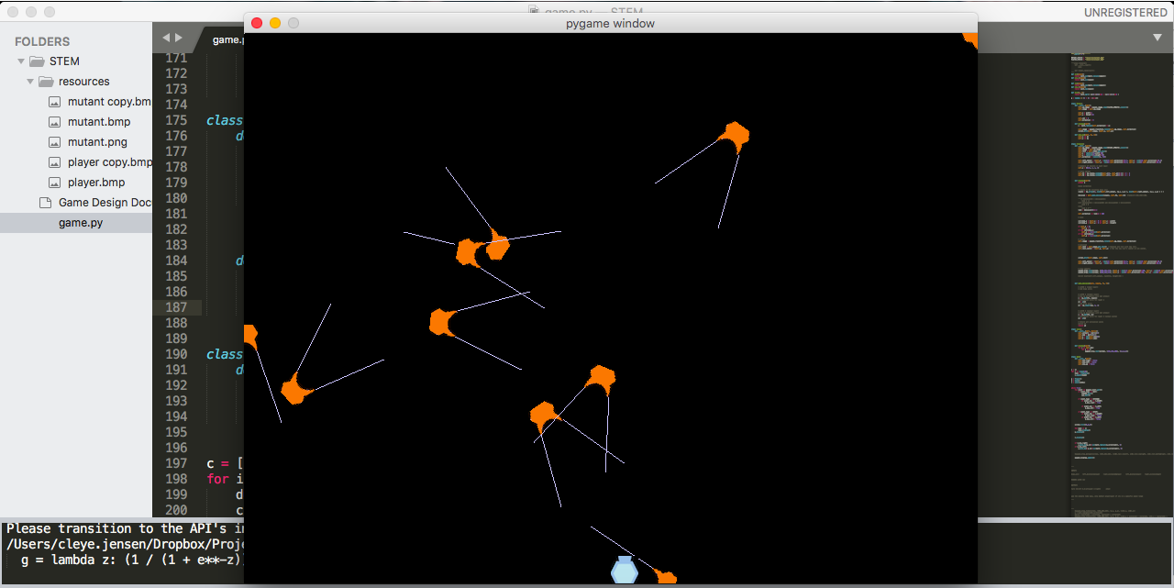

Game Title

problems

first problem – how to rotate an image without it going everywhere, took a week to solve

what inputs and outputs should the nn have

INPUTS bias_unit left_distance2player right_distance2player left_distance2wall right_distance2wall

HIDDEN LAYER (4)

OUTPUTS turn (0-left 0.5-straight 1-right) shoot

problem: turn was 3 different outputs (left right straight), creatures starting going straight it looked unnatural

solution: create 0-1 turning values

fitness:

not touching wall

touching player

to do:

music

storyline

gui

game:

4 waves (a wave is 16 specimens of a species) come for each generation

species:

twirlers, sharpshooters

survive as many generations as possible

better start gui

borrowed button class off old program

problem: bullets were sensed even when moving away from them

added angles to sensor, add periphery value

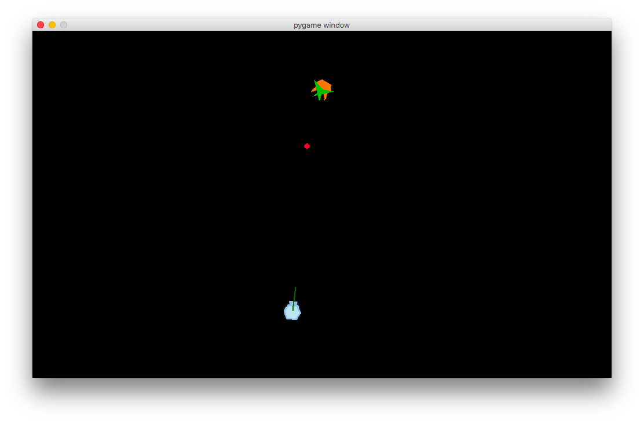

added distance to player, bullet sensing, wall sensing as parameters

wall proximity function

added speed output

I’ve had the idea that the creature has limited energy or life and this is expended the faster it moves, and also shooting it depletes its life by a random amount

if that’s the case I need an overarching class for movable objects which player and creatures inherit from

techniques:

try lure them into walls

move around them to get beind their back

fitness starts at 0:

reward:

damage done on player

average distance to player

time with player in sight

ability to sense bullets and dodge them

punish:

being stationary

running into walls

hitting bullets

some creatures drop powerups when they die

Creature

- update

- display

- calculate_fitness

-